4.1 Goniometrische cirkel en radialen

$$\boxed{\boxed{2π\text{ rad}={360}^{∘}} \boxed{π\text{ rad}={180}^{∘}} \boxed{\frac{π}{2}={90}^{∘}}}$$
$$\boxed{\boxed{α rad =α rad * \frac{180°}{π}} \boxed{ α ° =α graden * \frac{π}{180°}}}$$
Booglengte:
$$\boxed{s=α * r}$$
- r = straal
- $α$ = hoek in radialen
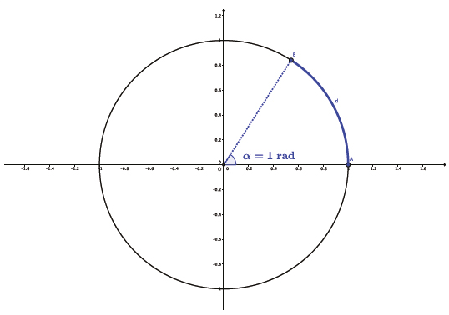

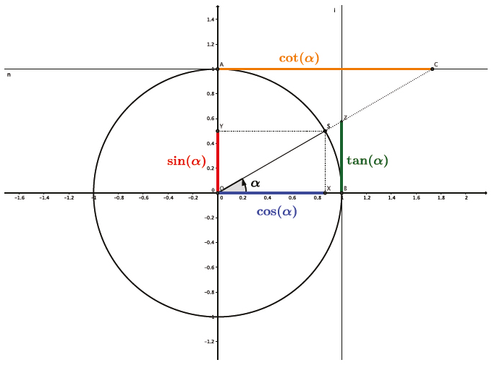
4.2 Sinus, cosinus, tangens en cotangens

Punt op de eenheidscirkel:
$$\boxed{P=cos (α) * sin (α)}$$
Fundamentele formule:
$$\boxed{\sin^{2}(α)+\cos^{2}(α)=1}$$
Tangens en cotangens:
$$\boxed{tan (α)=\frac{sin (α)}{cos (α)}} \boxed{cot (α)=\frac{cos (α)}{sin (α)}}$$
Symmetrie:
$$\boxed{sin(-α)=-sin(α)} \boxed{cos(-α)=cos(α)}$$
$$\boxed{tan(-α)=-tan(α)} \boxed{cot(-α)=-cot (α)}$$
Perioden:
$$\boxed{tan(α+π)=tan (α)} \boxed{cot(α+π)=cot (α)}$$

Bijzondere waarden
$$α$$ | 0 | $$\frac{π}{6}=30°$$ | $$\frac{π}{4}=45°$$ | $$\frac{π}{3} =60°$$ | $$\frac{π}{2} = 90°$$
$$sin α$$ | 0 | $$\frac{1}{2}$$ | $$\frac{\sqrt{2}}{2}$$ | $$\frac{\sqrt{3}}{2}$$ | 1
$$cos α$$ | 1 | $$\frac{\sqrt{3}}{2}$$ | $$\frac{\sqrt{2}}{2}$$ | $$\frac{1}{2}$$ | 0
$$tan α$$ | 0 | $$\frac{\sqrt{3}}{3}$$ | 1 | $$\sqrt{3}$$ | -

Goniometrische vergelijkingen

$$\boxed{sin (x)=A⇒x=B+2kπ \text{of} x=π-B+2kπ}$$
$$\boxed{cos (x)=A⇒x=B+2kπ \text{of} x=-B+2kπ}$$
$$\boxed{tan (x)=A⇒x=B+kπ}$$
$$\boxed{cot (x)=A⇒x=B+kπ}$$

4.3 Verwante hoeken

Complementair: $α+β=\frac{π}{2}$

$$\boxed{sinβ=cosα} \boxed{cosβ=sinα}$$

Anti-complementair: $|α-β|=\frac{π}{2}$

$$\boxed{sinβ=cosα} \boxed{cosβ=-sinα}$$

Supplementair: $α+β=π$

$$\boxed{sin(π-α)=sinα} \boxed{cos(π-α)=-cosα}$$
$$\boxed{tan(π-α)=-tanα} \boxed{cot(π-α)=-cotα}$$

Anti-supplementair: $|α-β|=π$

$$\boxed{sin(π+α)=-sinα} \boxed{cos(π+α)=-cosα}$$
$$\boxed{tan(π+α)=tanα} \boxed{cot(π+α)=cotα}$$

4.4 Som-, verschil- en dubbele hoekformules
Som:
$$\boxed{sin(α+β)=sinαcosβ+cosαsinβ}$$
$$\boxed{cos(α+β)=cosαcosβ-sinαsinβ}$$
$$\boxed{tan(α+β)=\frac{tanα+tanβ}{1-tanαtanβ}}$$
Verschil:
$$\boxed{sin(α-β)=sinα cosβ-cosα sinβ}$$
$$\boxed{cos(α-β)=cosα cosβ+sinα sinβ}$$
$$\boxed{tan(α-β)=\frac{tanα-tanβ}{1+tanα tanβ}}$$
Dubbele hoek:
$$\boxed{sin(2α)=2.sin α.cos α}$$
$$\boxed{cos(2α)=\cos^{2}α-\sin^{2}α}$$
$$\boxed{tan(2α)=\frac{2tanα}{1-\tan^{2}α}}$$

4.5

Rechthoekige driehoek
$$\boxed{sinα=\frac{a}{c} cosα=\frac{b}{c} tanα=\frac{a}{b}}$$
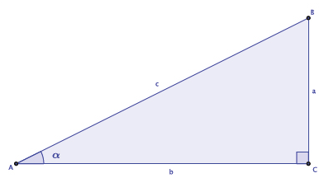
Pythagoras:
$$\boxed{a^{2}+b^{2}=c^{2}}$$

4.6 Willekeurige driehoek
Sinusregel: ( meer hoeken dan zijden gegeven )
$$\boxed{\frac{a}{sin(α)}=\frac{b}{sin(β)}=\frac{c}{sin(γ)}}$$
Cosinusregel: ( meer zijden dan hoeken )
$$\boxed{a^{2}=b^{2}+c^{2}-2bc cos(α)}$$
$$\boxed{b^{2}=a^{2}+c^{2}-2ac cos(β)}$$
$$\boxed{c^{2}=a^{2}+b^{2}-2ab cos(γ)}$$

Oppervlakte:
$$\boxed{O=\frac{1}{2}bc sin(α)}$$
$$\boxed{O=\frac{1}{2}ab sin(γ)}$$
$$\boxed{O=\frac{1}{2}ac sin(β)}$$
